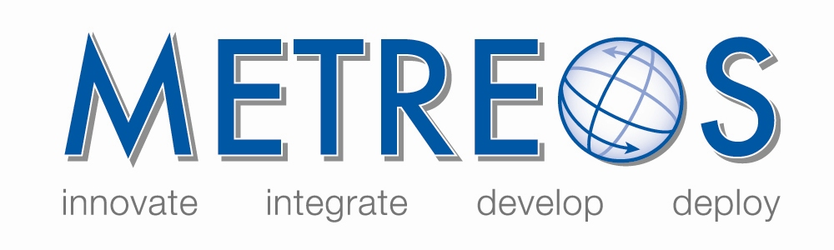
IP Communications Applications for Business Advantage

Metreos Communications Environment 2.1
Application Suite User Guide

Copyright © 2005 Metreos Corporation
All Rights Reserved

Proprietary and Confidential Information
For Release under NDA Only

Table of Contents

Table of Contents 2
Preface 4
Intended Audience 4
Information This Book Contains 4
Style and Formatting Conventions 4
License/Certification Information 5
1. The Metreos Application Suite 10
Metreos ActiveRelay 10
Metreos ClickToTalk 10
Metreos Intercom 10
Metreos RapidRecord 10
Metreos ScheduledConference 11
Metreos VoiceTunnel 11
2. Application Suite Login and Configuration 12
Before You Begin 12
Logging In 12
3. Metreos ActiveRelay 14
Active Relay Features 14
Before You Begin 14
Using ActiveRelay 14
Swapping a Call 14
4. Metreos ClickToTalk 16
Before You Begin 17
Installing the Outlook Plug-In 17
Configuring the Outlook Plug-In 17
Verifying Connectivity 18
If connectivity was not established 19
Making a Call 19
Recording Your Call 20
Conference Calls 20
5. Metreos Intercom 21
Before You Begin 21
Initiating an Intercom Broadcast 21
Receiving an Intercom Broadcast 21
6. Metreos RapidRecord 22
Enabling Recording of Calls 22
Stop and Restart Recording 22
Listening to Recorded Calls 23
7. Metreos ScheduledConference 25
Scheduling a Conference 25
Dialing Into a Scheduled Conference 28
8. Metreos VoiceTunnel 29
Using VoiceTunnel 29
Logging into VoiceTunnel 29
Billing Codes 29
Ending a Call 29
VoiceTunnel Error Conditions 30

www.metreos.com | Part Number M-2400-ASUG-01
 | 8/2005

Information in this document is subject to change without notice.

Copyright © 2005 Metreos Corporation. All rights reserved. Metreos trademarks marked with a ® or © herein are registered or protected trademarks of Metreos in the U.S. and foreign countries. All other trademarks in the document are the property of their respective owners.

Preface
This book explains how to deploy and configure the Metreos Application Suite to the Metreos Communications Environment (MCE). This book also describes each application in the suite and how each application is used.

Intended Audience
This document describes the use of each of the IP telephony applications in the Metreos Application Suite™, and as such is targeted to the users of those applications. For Application Suite configuration instructions, refer to the Metreos Application Suite Administration Guide.

Information This Book Contains
The MCE Developer Guide is organized into the following Chapters:

- Chapter 1 The Metreos Application Suite
- Chapter 2 Application Suite Login and Configuration
- Chapter 3 Metreos ActiveRelay
- Chapter 4 Metreos ClickToTalk
- Chapter 5 Metreos Intercom
- Chapter 6 Metreos RapidRecord
- Chapter 7 Metreos ScheduledConference
- Chapter 8 Metreos VoiceTunnel

Style and Formatting Conventions
The following typographical components are used for defining special terms and command syntax:

Convention | Description
Bold typeface | Represents literal information such as  - Information and controls displayed on screen, including menu options, windows dialogs and field names  - Commands, file names, and directories  - In-line programming elements, such as class names and XML elements when referenced in the main text
Italic typeface | Italics typeface is used to denote  - A new concept  - A variable element such as filename.mca. In this example, filename represents the filename and .mca is the extension.  - A reference to a chapter or section heading
Sans serif typeface | Denotes code or code fragments
… (ellipsis) | Denotes omitted material
UPPERCASE | Denotes keys and keystroke combinations such as CTRL+ALT+DEL.

License/Certification Information

Metreos Corporation

End User License

Important – Use of this Software is subject to license restrictions.
Carefully read this license agreement before using the software.

This End User License Agreement (the “Agreement”) is a legal agreement between you, either individually or as an authorized representative of the company or organization acquiring the license, and Metreos Corporation (“Metreos”). USE OF SOFTWARE INDICATES YOUR COMPLETE AND UNCONDITIONAL ACCEPTANCE OF THE TERMS AND CONDITIONS SET FORTH IN THIS AGREEMENT. If you do not agree to these terms and conditions, promptly return or, if electronically received, certify destruction of the Software and all accompanying items within five days after receipt of Software and you will receive a full refund of the applicable license fees paid.

1. License Grant

a. The software programs you are installing, downloading, or have acquired with this Agreement, including any related equipment or hardware, documentation, updates, upgrades, modifications, revisions, copies and design data (“Software”) are copyrighted, trade secret and confidential information of Metreos and its licensors who maintain exclusive title to all Software and retain all rights not expressly granted by this Agreement. Metreos grants to you, subject to payment of appropriate license fees, a non-exclusive, non-transferable, internal-use only, term license to use the Software owned or distributed by Metreos in machine readable, object-code form on the computer hardware or at the site(s) for which an applicable license fee has been paid, as authorized by Metreos.

b. To the extent that you design applications that operate on the Metreos Communications Environment (the “MCE”), Metreos grants you a non-exclusive, non-transferable, internal-use only, term license to use the Software, including the MCE, for the purposes of operating such programs, subject to payment of appropriate license fees.

c. The license granted herein is contingent on your (or your organization’s) continued acceptance and subscription to the maintenance and support terms provided by Metreos. Termination by you or your organization of ongoing maintenance and support requirements terminates the license granted herein.

2. Restrictions and Intellectual Property Ownership

a. You may not (i) remove or modify any notice of Metreos’ proprietary rights, (ii) re-license, rent, lease, timeshare, or act as a service bureau or provide subscription services for the Software, (iii) use the Software to provide third-party training, except for training agents and contractors authorized under this Agreement; (iv) assign this Agreement or give the Software or an interest in the Software to another individual or entity; (v) cause or permit reverse engineering or decompilation of the Software; (vi) disclose results of any Software benchwork tests without Metreos’ prior written consent; or (vii) modify the Software or any portions thereof without Metreos’ prior written consent.

b. The Software, which is copyrighted, and any modifications, upgrades, or updates thereto, is the sole and exclusive property of Metreos and is a valuable asset and trade secret of Metreos. Metreos retains all ownership and intellectual property rights to the Software and to any modifications, upgrades, or updates thereto. Except for the rights granted in herein above, you shall have no right, title, or interest of any kind in or to the Software.

c. Metreos may audit your use of the Software. If Metreos gives you or your organization reasonable advance written notice, you agree to cooperate with the audit, and to provide reasonable assistance and access to information. You agree to immediately remit any underpaid license and technical support fees determined as the result of such audit.

3. Term and Termination.

a. This Agreement remains effective until expiration or termination. This Agreement will immediately terminate upon notice if you exceed the scope of the license granted or otherwise fail to comply with the provisions in sections 1 and 2 above. For any other material breach of the Agreement, Metreos may terminate this Agreement if you are in breach and fail to cure the breach within thirty (30) days of written notification. If Software is provided for a limited term use, this Agreement will automatically expire at the end of the authorized term.

b. Upon termination of this Agreement for any reason, you shall within ten (10) business days return to Metreos all Software. Additionally, you agree to delete from any permanent machine storage (i.e., hard disk) previously loaded copies of the Software in all forms. Upon request of Metreos, you shall certify in writing that all copies of the Software and associated documentation have been destroyed or returned to Metreos. The indemnity and limitation of liability obligations hereunder, as well as your obligations with respect to confidential treatment of the Software and Metreos’ trade secrets, other intellectual property, and proprietary information, shall survive the termination of this Agreement.

4. Limited Warranty.

a. Metreos warrants that the Software will substantially operate as described in the applicable Software documentation for ninety (90) days after Metreos delivers it to you. THE WARRANTY HEREIN IS EXCLUSIVE AND IN LIEU OF ALL OTHER WARRANTIES, WHETHER EXPRESS OR IMPLIED, INCLUDING THE IMPLIED WARRANTIES OF MERCHANTABILITY AND FITNESS FOR A PARTICULAR PURPOSE. METREOS MAKES NO WARRANTY THAT ANY SOFTWARE WILL PERFORM ERROR-FREE OR UNINTERRUPTED, OR THAT ALL ERRORS THEREIN CAN OR WILL BE CORRECTED. METREOS FURTHER DISCLAIMS ANY IMPLIED WARRANTIES ARISING FROM COURSE OF PERFORMANCE, COURSE OF DEALING OR USAGE OF TRADE.

b. For any breach of the above warranty, Metreos’ entire liability and your exclusive remedy shall be, at Metreos’ option, either (1) refund of the fees paid upon return of the Software to Metreos, or (2) correction or replacement of the Software that does not meet this limited warranty, provided you have complied with the terms of this Agreement.

5. Indemnity

a. Metreos will defend and indemnify you against a claim that any Software, infringes a patent or copyright, provided that: (i) you notify Metreos in writing within thirty (30) days of the claim; (ii) Metreos has sole control of the defense and all related settlement negotiations; and (iii) you provide Metreos with the assistance, information, and authority reasonably necessary to perform the above; reasonable out-of-pocket expenses incurred by you in providing such assistance will be reimbursed by Metreos.
b. Metreos shall have no liability for any claim of infringement resulting from: (i) your use of a superseded or altered release of the Software if infringement would have been avoided by the use of a subsequent unaltered release of the Software which Metreos provides to you; or (ii) any information, design, specification, instruction, software, data, or material not furnished by Metreos or (iii) any combination of the Software with other hardware, software or processes that, but for the combination, the Software would not be infringing.
c. In the event that some or all of the Software is held or is believed by Metreos to infringe, Metreos shall have the option, at its expense: (i) to modify the Software to be non-infringing; or (ii) to obtain for you a license to continue using the Software. If it is not commercially feasible to perform either of the above options, then Metreos may require from you return of the infringing Software and all rights thereto. Upon return of the infringing Software to Metreos, you may terminate the Agreement with ten (10) days’ written notice and you shall be entitled to a pro-rata refund of the fees paid for the infringing Software. This subsection sets forth Metreos’ entire liability and exclusive remedy for infringement.
d. You will defend and indemnify Metreos and its licensors against any claim incurred by, borne by or asserted against Metreos or its licensors that relates to or results from (i) your use of the Software, (ii) any intentional or willful conduct or negligence by you or (iii) any breach of an applicable representation, covenant or warranty contained herein.
e. Should the party seeking indemnification (“Indemnitee”) reasonably determine that the party from whom indemnity is sought (“Indemnitor”) has failed to assume the defense of any claim referenced herein, Indemnitee shall have the right to assume such defense and have all expense and cost of the defense reimbursed by Indemnitor, including reasonable attorneys fees.

6. Confidentiality

The Software contains proprietary and confidential information of Metreos as well as trade secrets owned by Metreos. You agree to hold the Software in strict confidence and not to disclose the Software in any way except as expressly permitted hereunder. You agree to protect the Software at least to the same extent that you protect your similar confidential information, but in no event less than reasonable care. You further agree that you will not, directly or indirectly, copy the structure, sequence, or organization of the Software, nor will you copy any portion of the Software or related documentation to produce software programs that are substantially similar to the Software.

7. LIMITATION OF LIABILITY

EXCEPT WHERE THIS EXCLUSION OR RESTRICTION OF LIABILITY WOULD BE VOID OR INEFFECTIVE UNDER APPLICABLE LAW, IN NO EVENT WILL METREOS BE LIABLE FOR ANY INDIRECT, INCIDENTAL, SPECIAL, OR CONSEQUENTIAL DAMAGES, OR DAMAGES FOR LOSS OF PROFITS, REVENUE, DATA, OR USE, INCURRED BY YOU OR ANY THIRD PARTY, WHETHER IN AN ACTION IN CONTRACT OR TORT, EVEN IF METREOS OR ANY OTHER PERSON HAS BEEN ADVISED OF THE POSSIBILITY OF SUCH DAMAGES. METREOS’ LIABILITY FOR DAMAGES HEREUNDER SHALL IN NO EVENT EXCEED THE AMOUNT OF FEES PAID BY YOU FOR THE SOFTWARE OR SERVICE GIVING RISE TO THE CLAIM. IN THE CASE WHERE NO AMOUNT WAS PAID, METREOS SHALL HAVE NO LIABILITY FOR ANY DAMAGES WHATSOEVER.

8. Assignment; Jurisdiction.

This Agreement will be binding upon, and will inure to the benefit of, the permitted successors and assigns of each party hereto. You may not assign, delegate, transfer, or otherwise convey this Agreement, or any of its rights hereunder, to any entity without the prior written consent of Metreos, and any attempted assignment or delegation without such consent shall be void. This Agreement, and all matters arising out of or relating to this Agreement, shall be governed by the laws of the State of Texas, United States of America. Any legal action or proceeding relating to this Agreement shall be instituted in any state or federal court in Travis or Dallas County, Texas, United States of America. Metreos and you agree to submit to the jurisdiction of, and agree that venue is proper in, the aforesaid courts in any such legal action or proceeding.

9. Severability; Waiver

In the event any provision of this Agreement is held to be invalid or unenforceable, the remaining provisions of this Agreement will remain in full force. The waiver by either party of any default or breach of this Agreement shall not constitute a waiver of any other or subsequent default or breach. Except for actions for nonpayment or breach of either party’s intellectual property rights, no action, regardless of form, arising out of this Agreement may be brought by either party more than two years after the cause of action has accrued. The headings appearing in this Agreement are inserted for convenience only, and will not be used to define, limit or enlarge the scope of this Agreement or any of the obligations herein.

10. Restricted Rights Notice.

The Software is commercial in nature and developed solely at private expense. The Software is delivered as "Commercial Computer Software" as defined in DFARS 252.227-7014 (June 1995) or as a commercial item as defined in FAR 2.101(a) and as provided with only such rights as are provided in this Agreement, which is Metreos’ standard commercial license for the Software. Technical data is provided with limited rights only as provided in DFAR 252.227-7015 (Nov. 1995) or FAR 52.227-14 (June 1987), whichever is applicable.

11. Payment; Interpretation; Compliance.

You will pay all amounts invoiced, in the currency specified on the invoice, within 30 days from the date of such invoice. This Agreement constitutes the complete agreement between the Parties and supersedes all previous and contemporaneous agreements, proposals, or representations, written or oral, concerning the subject matter of this Agreement. This Agreement may not be modified or amended except in a writing signed by a you and Metreos; no other act, document, usage, or custom shall be deemed to amend or modify this Agreement. It is expressly agreed that the terms and conditions of this Agreement supersede the terms of any purchase order. Each party agrees to comply with all relevant export laws and regulations of the United States and the country or territory in which the Services are provided (“Export Laws”) to assure that neither any deliverable, if any, nor any direct product thereof is (a) exported, directly or indirectly, in violation of Export Laws or (b) intended to be used for any purposes prohibited by the Export Laws, including without limitation nuclear, chemical, or biological weapons proliferation. Each party agrees to comply with all federal, state and local laws and regulations applicable to this Agreement. Each party represents and warrants that it is qualified to do business in the geographies in which it will perform its obligations under this Agreement, and will obtain all necessary licenses and permits, and satisfy any other legal, regulatory and administrative requirements, necessary to its performance hereunder.

The Metreos Application Suite
The Metreos Application Suite™ is a collection of the most in-demand voice over IP applications for the enterprise. Each application in the suite is a complete IP telephony application, ready to deploy and run at your site. The applications are built using Metreos visual tools and execute within the Metreos runtime environment. Each application is therefore easily and quickly customizable by your staff or integrator, should you wish to do so.

The Metreos Application Suite includes the following IP telephony business applications.

Metreos ActiveRelay
Metreos ActiveRelay™ lets you receive calls at a single number, regardless of your physical location. It can, for example, bridge your cellular telephone to your office telephone and simultaneously ring both phones, allowing you to answer either phone.

Once connected, you can easily transfer the call to other devices that are configured with ActiveRelay. The call also does not exhibit multiple ring sequences as do older style call forwarding applications.

Metreos ClickToTalk
Metreos ClickToTalk™ is a speed dialing application allowing calls to any party in a contact list with a single click. Metreos ClickToTalk can be used by anyone in a Cisco CallManager group using a Cisco 7940, 7960, or 7970 IP telephone.

A ClickToTalk user can call a Microsoft Outlook contact by highlighting a contact and clicking a button on the Outlook toolbar. ClickToTalk then dials the selected contact from the user’s IP phone. Conferencing and recording of calls are also supported. Recorded calls can be sent by e-mail to all call participants.

Metreos Intercom
Metreos Intercom™ permits instant communication over IP phones without the need to dial a number. Users select from a contact group on the IP phone display, and audio connectivity is established.

Metreos Intercom can also be configured to act as a group paging system for broadcasting voice messages or pages in a fashion similar to a traditional paging system. Using the TalkBack feature, an intercom listener can press the Reply button and instantly conference with each party in the intercom group.

Metreos RapidRecord
Metreos RapidRecord™ automatically records calls placed to and from a configured group of devices, permitting seamless, hands-off call recording. Recorded calls can be played back either from a Web interface, or directly from the IP phone that placed or received the call.

Metreos ScheduledConference
Metreos ScheduledConference™ is a Web-scheduled dial-in and dial-out conferencing system. Conferences can be scheduled from an easy-to-use Web interface, eliminating any need for operator or administrative assistance. Features include the adding of conference parties, party mute and unmute, and removal of participants from conference.

Metreos VoiceTunnel
Metreos VoiceTunnel™ allows a remote user to connect to any enterprise IP communications system and place calls as if they were local to the system. With Metreos VoiceTunnel you can

- Place all calls locally, avoiding international and long-distance toll charges
- Authenticate call usage and apply a broad range of policies to the billing and accounting of communications costs
- Manage, monitor, and report on the use of the communications system.

Application Suite Login and Configuration

Before You Begin
Because each application in the Metreos Application Suite runs in the context of the Metreos runtime environment, you should ensure that the Metreos runtime environment is active.

Logging In
Some applications in the suite require configuration through the Metreos Application Suite Administration console. To schedule a conference using Metreos ScheduledConference, for example, log into the administration console and schedule your conference from the Metreos ScheduledConference page.

After navigating to the administration URL, http://yourserver/appsuiteadmin, the system presents a login page:

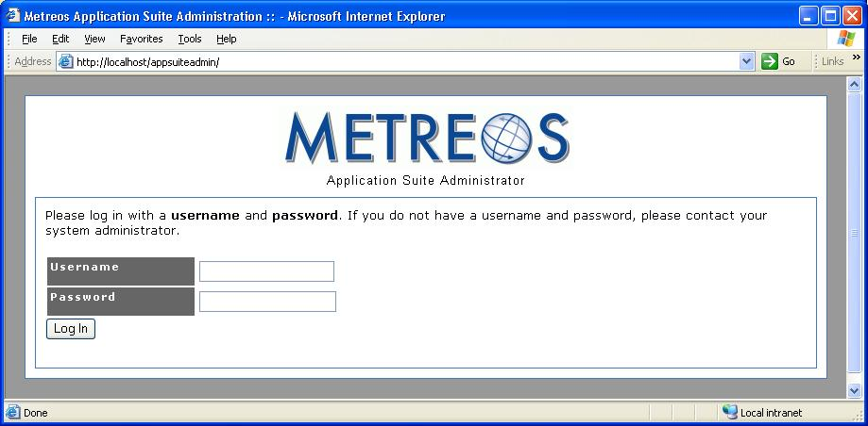
Figure 1: Application Suite Login
Your administrator should supply an initial user name and password to access the administration console. After logging in you can access all Metreos application configuration options as shown:
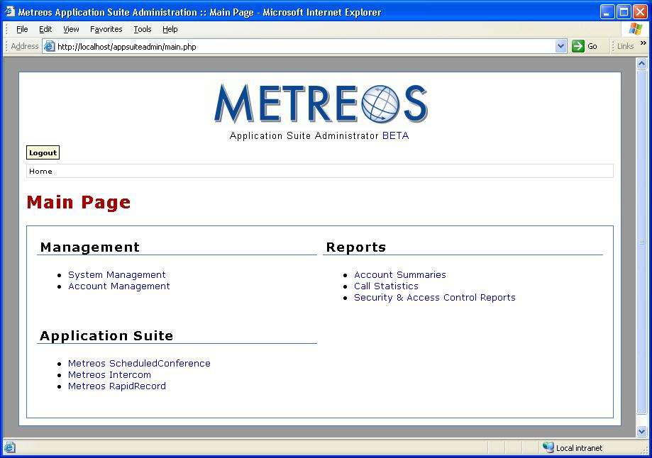
Figure 2: Application Suite Administration Main Page
Refer to Metreos Communication Environment 2.1 Application Suite Administrator Guide for information about configuring Metreos Applications.

Metreos ActiveRelay

Metreos ActiveRelay lets you receive calls at a single number, regardless of your physical location. It can, for example, bridge your cellular telephone to your office telephone and simultaneously ring both phones, allowing you to answer either phone.

Once connected, you can easily transfer the call to other devices that are configured with ActiveRelay. The call also does not exhibit multiple ring sequences as do older style call forwarding applications.

Active Relay Features
- One-number portability – Your contacts can reach you at a single number.
- Multiple endpoints – Your contact’s call can ring any number of phones.
- Switch phones without disruption – You can begin talking on your mobile phone and seamlessly switch to your office phone.
- Standards independent – TDMA, CDMA, GSM are supported.
- Caller ID push – Your calling number is forwarded to any phone so equipped.

Before You Begin
Before you can use Metreos ActiveRelay, the Metreos Application Suite and Cisco CallManager must be appropriately configured. If you are to be the recipient of calls forwarded by ActiveRelay, your primary telephone must be registered as such with the Application Suite. The numbers of any external phones to which you want your calls to be relayed must also be registered as external numbers. Refer to the Edit Account of the Metreos Communications Environment 2.1 Application Suite Administration Guide, for details.

Using ActiveRelay
When a caller dials the number of the primary device registered with the Metreos Application Suite, your primary phone will ring. After a brief delay all other phones, configured as external numbers, will also ring.

Swapping a Call
Once you have answered the call on any phone, you may swap the call to any of your configured IP phones.

To swap the call from an external number to your primary device, select ActiveRelay from Services menu displayed on the phone to which you want to swap the call. A Swap key will then be visible on the phone display. Press Swap. The system will play a series of tones on the original phone, indicating that the call swap request is pending. Press the pound key (##) twice on the phone from which the call is to be swapped to confirm the transfer.

To swap a call from an external number (such as your cell phone) to another external phone, select ActiveRelay on the phone to which you want to swap the call. The phone will prompt you for your account username and password. The Swap option will not be available until you enter the requested information.

A phone may be subscribed to the ActiveRelay service but not configured as a device associated with a Metreos Application Suite account. In such cases, you will be prompted by the phone menu for the number of the phone to which you want to swap the call. Once you have entered the number you will be prompted for your account username and password.

Metreos ClickToTalk
Metreos ClickToTalk is a speed dialing application allowing calls to any party in a contact list with a single click. Metreos ClickToTalk can be used by anyone in a Cisco CallManager group using a Cisco 7940, 7960, or 7970 IP telephone.

A ClickToTalk user can call a Microsoft Outlook contact by highlighting a contact and clicking a button on the Outlook toolbar. ClickToTalk then dials the selected contact from the user’s IP phone. Conferencing and recording of calls are also supported. Recorded calls can be sent by e-mail to all call participants.

Integration with Cisco IP Phone Services enables the display of called party state on the phone. If, for example, an invited conferee did not answer, a message is displayed on your phone indicating that the party did not answer. A robust XML-over-HTTP API is also available, permitting easy integration into other applications such as instant messaging.

Metreos ClickToTalk ships with a plug-in for Microsoft Outlook. Other such plug-ins can be easily developed by your staff or integrator to permit calls from any HTTP-capable endpoint.

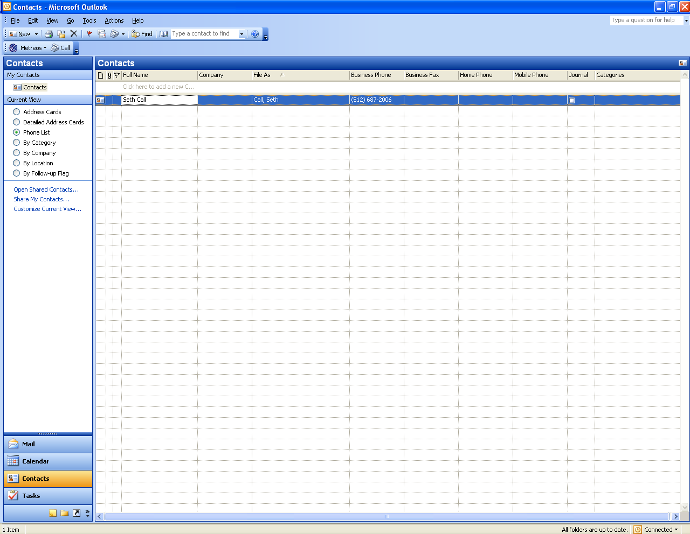
Figure 3: ClickToTalk Presence on Outlook Toolbar

Before You Begin
Before installing the ClickToTalk Outlook plug-in, you or the administrator should ensure the following:
- The Metreos runtime environment is running, and that the administrator has informed you of the IP address and port number ClickToTalk should use for connectivity.
- You or the administrator has registered a Metreos Application Suite account for you, and that you have the user name and password for this account at hand. Refer to the Metreos Communications Environment 2.1 Application Suite Administration Guide for more information.
- You or the administrator has registered the IP phone to be used to dial your ClickToTalk calls, as the primary device in your Metreos Application Suite account.
- You or the administrator has associated this same IP phone device with a Cisco CallManager user account. Refer to Cisco documentation for more information.

Installing the Outlook Plug-In
Before installing the plug-in, ensure that Microsoft Outlook is not running on your desktop. Also, if a previous version of the Metreos plug-in for Outlook exists, it should be uninstalled. To do so, navigate to Windows Start menu → Control Panel → Add or Remove Programs → Metreos Click-to-Talk Plug-in, and click the Remove button.

Your Metreos Application Suite administrator can provide the installation file for the ClickToTalk Outlook plug-in. The installation file name is setup.exe, unless renamed by the administrator. Double-click the setup.exe file to begin installation. The system displays an install wizard to guide you through the installation process.

When the installation is complete, start Microsoft Outlook and a Metreos button will be displayed on the Outlook toolbar.

Configuring the Outlook Plug-In
Before using ClickToTalk the first time, you must configure it with the information required to

- Log you into the Metreos Application Suite server
- Forward to you any call recordings you request

The configuration information will be saved in the registry. It is therefore necessary to configure the Outlook plug-in only after the initial installation of ClickToTalk, or in the event that your login information changes.

Clicking the Metreos button on the Outlook toolbar, displays a menu with a single item: Settings… Click Settings… to launch the Metreos ClickToTalk Settings dialog as shown:

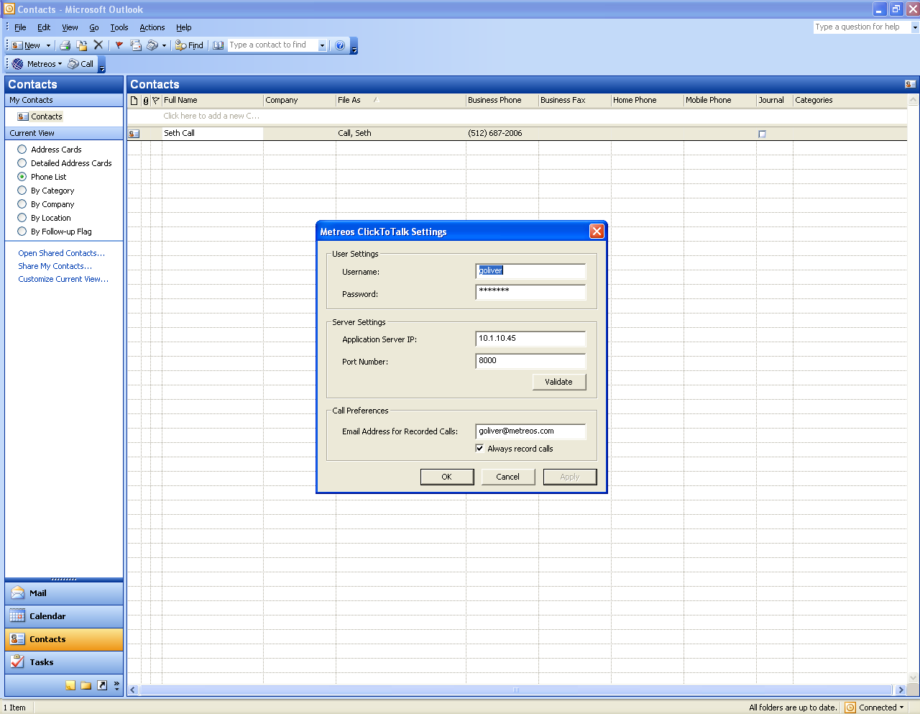
Figure 4: Metreos ClickToTalk Settings
Enter the following information:
- Username – Enter your Metreos Application Suite username supplied by the administrator.
- Password – Enter your Metreos Application Suite password supplied by the administrator.
- Metreos Application Server – Enter the Metreos Application Suite IP address supplied by the administrator.
- Port Number – Enter the Metreos Application Suite port number supplied by the administrator.
- Email Address for Recorded Calls/Always record calls – Enter the e-mail address to which you want your requested call recordings sent.
- Always record calls – Check this box if you want to record all the calls you initiate.

Click the Validate button, to verify connectivity.

Verifying Connectivity
Clicking Validate on the Metreos ClickToTalk Settings dialog ensures that connectivity to the Metreos Application Suite runtime environment can be established. A progress bar will be displayed, after which the system will present a message indicating whether a connection will have been established. If successful, the one-time setup is complete.

If connectivity was not established
If connectivity could not be established, ensure that

- The Metreos runtime environment is active.
- You have entered the correct IP address and port number in the Metreos ClickToTalk Settings dialog (Figure 4) for the Metreos runtime environment
- Your Metreos Application Suite user account has a password associated with the account.
- You have entered the correct account name and password for your Metreos Application Suite user account in the Metreos ClickToTalk Settings dialog.

Making a Call
To make a call, select an entry in your contact list, and click the Call button located on the ClickToTalk Outlook toolbar. ClickToTalk presents a dialog with the contact information, which you can modify if necessary:

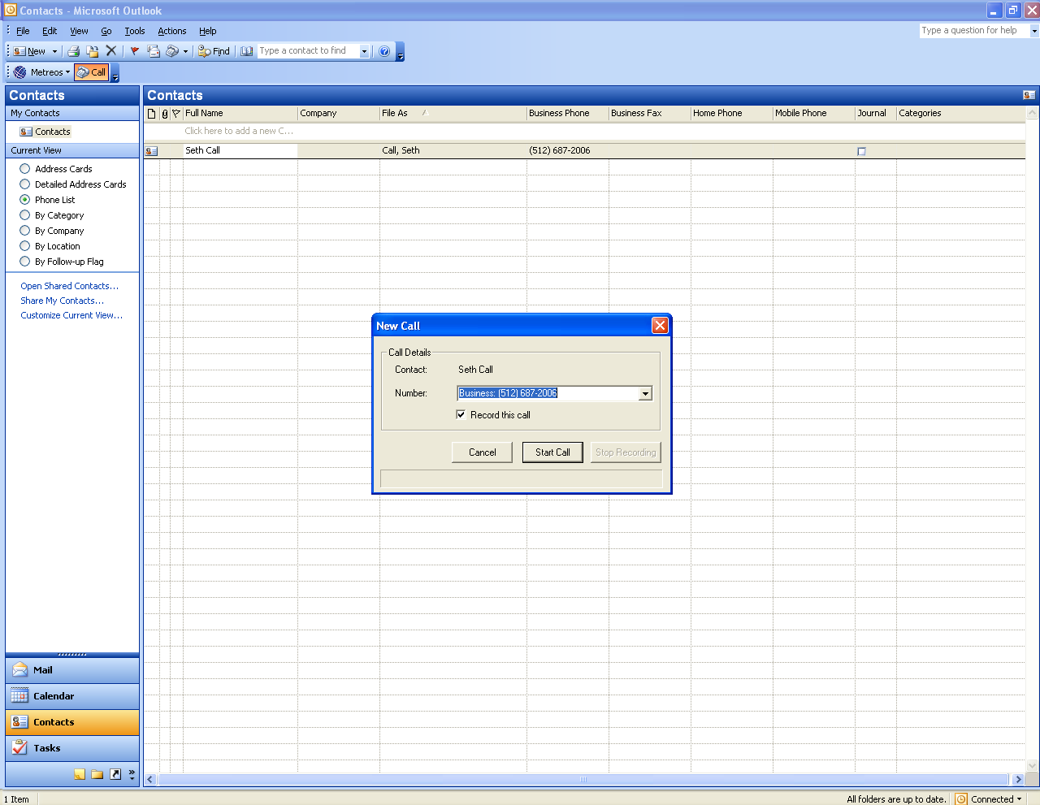
Figure 5: Metreos ClickToTalk Contact Dialog
The contact telephone number that you can modify will be displayed. Your IP phone will dial the selected party and begin talking when the call is answered.

Recording Your Call
When you click to talk, a dialog is displayed with the contact telephone number. To record the call, check the Record this call box.

Note: If you specified that all calls were to be recorded in the ClickToTalk Settings, it is not necessary to specify Record this call again here.

To stop recording the call, press the Stop Recording button, also found on the contact dialog.

Conference Calls
To begin a conference call, select multiple (up to four) entries from your contact list and click to talk:

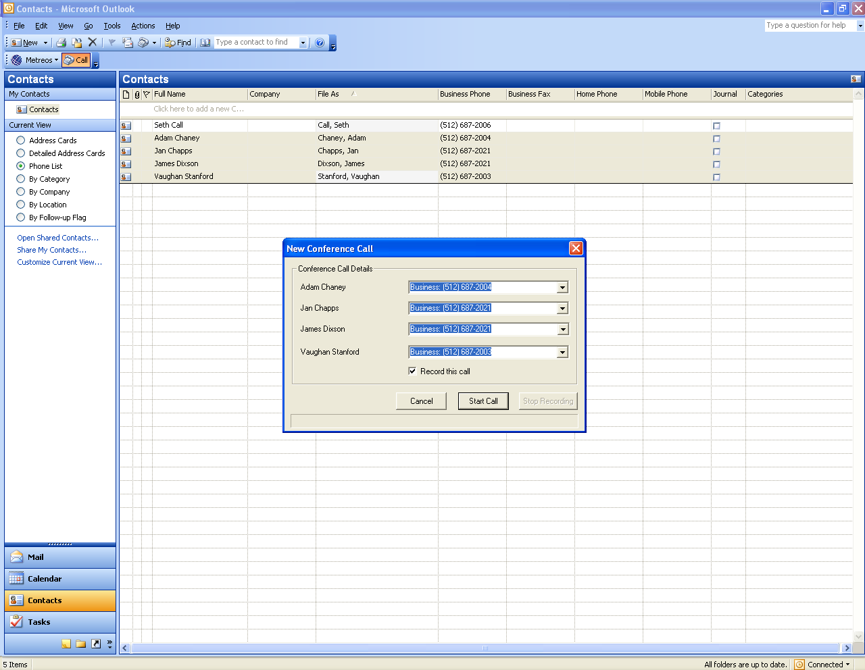
Figure 6: Metreos ClickToTalk Conference Call
If one or more parties fail to answer, a message ClickToTalk will present a message on your phone display indicating which contacts did not answer. Refer to Recording Your Call for instructions on recording your conference call.

Metreos Intercom

Metreos Intercom permits instant communication over IP phones without the need to dial a number. Users select from a contact group on the IP phone display, and audio connectivity is established.

Metreos Intercom can also be configured to act as a group paging system for broadcasting voice messages or pages in a fashion similar to a traditional paging system. Using the TalkBack feature, an intercom listener can press the Reply button and instantly conference with each party in the intercom group.

Metreos Intercom uses the concept of an intercom group. To broadcast a Metreos Intercom message, select an intercom group you want to address and your message will be broadcast to the IP phone speaker of each member of the group. Intercom groups are created by the administrator. If the administrator has defined the group to be public, anyone can join or leave the group after it has been created. If the group is private, its membership is determined solely by the administrator.

Before You Begin
Before you can broadcast a message over Metreos Intercom, the administrator must first ensure that
- The Application Runtime Environment is active
- The Metreos Intercom IP phone service is installed on Cisco CallManager
- Your IP phone is subscribed to the Metreos Intercom IP Phone Service
- An intercom group exists to which you belong, or that you can join

See the Metreos Communications Environment 2.1 Application Suite Administration Guide for more information.

Initiating an Intercom Broadcast
To broadcast to a group

- Press the Services button on your IP phone
- Select Metreos Intercom from the phone Services menu
- Select the intercom group to which you wish to broadcast
- Begin talking. Your voice message is heard on the phone speaker of each group member
- When you are finished, press the Exit button

Receiving an Intercom Broadcast
When someone broadcasts a voice message to an intercom group to which you belong, you will hear the message on your speaker of your phone. If the administrator has enabled the talkback feature for this intercom group, a Reply button will be active on your phone display. When you want to speak to the group, press the Reply button and speak normally.

Metreos RapidRecord
Metreos RapidRecord automatically records calls placed to and from a configured group of devices, permitting seamless, hands-off call recording. Recorded calls can be played back either from a Web interface, or directly from the IP phone that placed or received the call.

Enabling Recording of Calls
The administrator enables or disables the recording of calls in accordance with the Metreos Application Suite user account configuration for each user. The Account Management section of the Metreos Communications Environment 2.1 Application Suite Administrator Guide provides details about user accounts. Each application suite user account can be configured to enable two features for Metreos RapidRecord:

- Record Calls
- Recordings Visible

When Record Calls is enabled, each call in which the user participates is recorded. When Recordings Visible is enabled, a button is enabled on the participant’s phone to stop and restart recording.

Warning: Do not simultaneously enable Metreos RapidRecord and Metreos ActiveRelay for the same user.

Stop and Restart Recording
When a user account is configured to enable recording and to display the Stop and Start buttons, a Stop button appears on your phone while a call is being recorded. When you press Stop, recording is interrupted and the Stop button is replaced by a Start button. If you press Start, recording resumes and the intervening gap in the recording is recovered. If you do not restart recording, the conversation subsequent to pressing Stop is discarded.

Listening to Recorded Calls
Use the following procedure to listen to call recordings:

- Sign into the Application Suite Administration Console, as described in Logging In on page16, and click the Metreos RapidRecord link on the Main Page. The Administrator displays a list of all recordings:

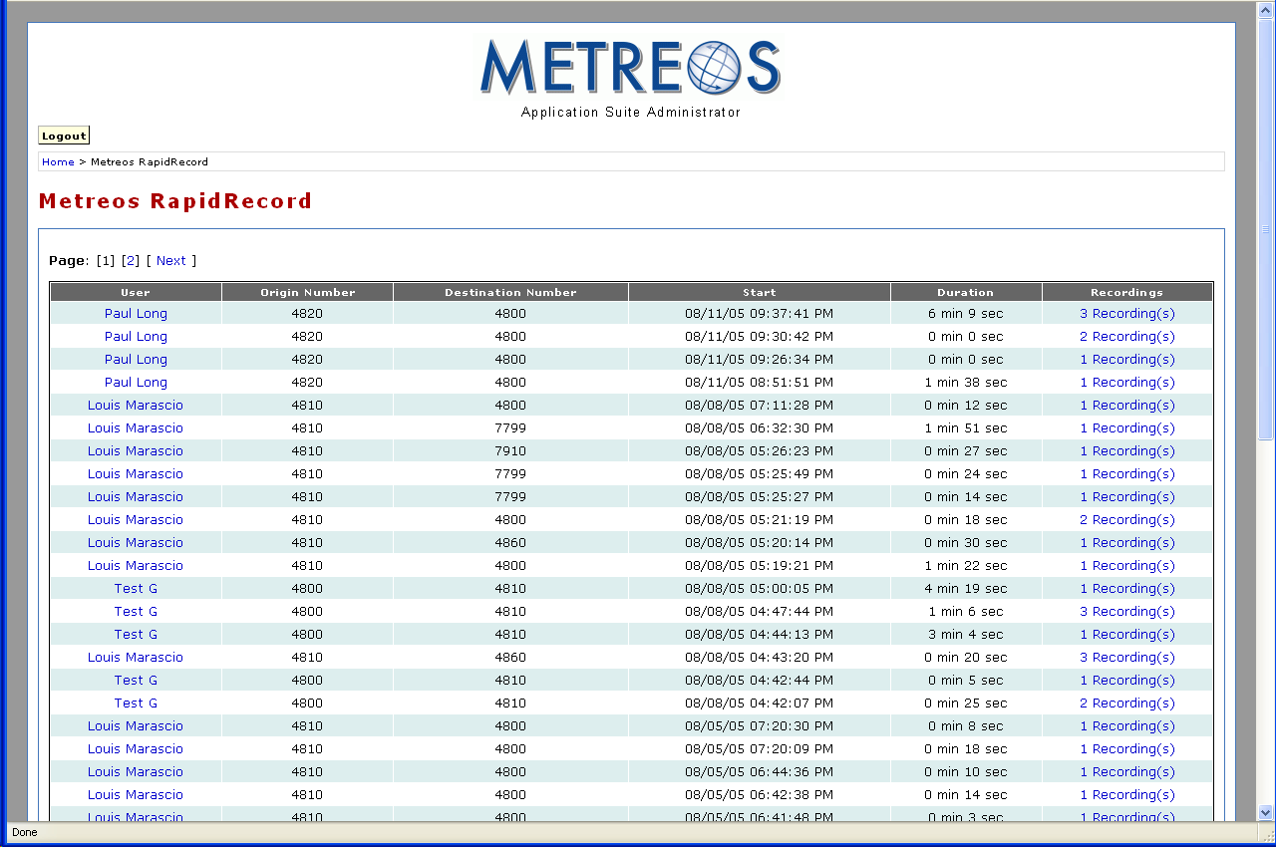
Figure 7: Example Recordings on Metreos RapidRecord Page
If the user presses the Stop button, RapidRecord creates an audio file. The file contains the audio segment from the beginning of the call to the time at which the Stop button is pressed. If the user does not press Record, the remainder of the conversation is discarded. If the user does press Record, RapidRecord creates a new audio segment.

The new segment contains the call audio from the time at which the Stop button was previously pressed to the time that either

- The call ends
or
- The Stop button is pressed again.

RapidRecord creates an audio file for each such segment of the call. The Recordings column lists the number of recording files for each call.

- Click the link presents a page containing information about each segment and a download link for each file:

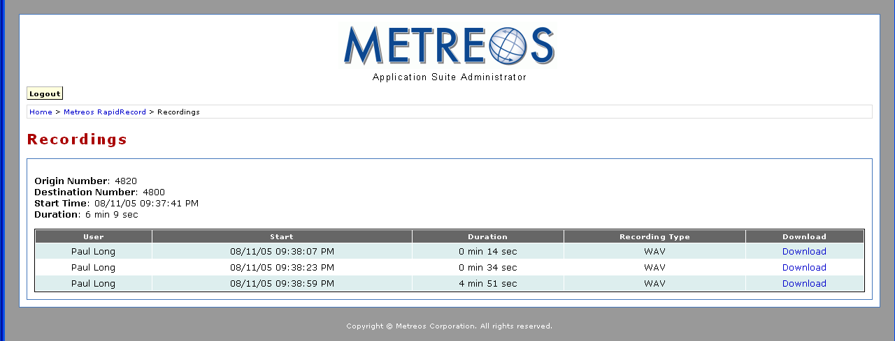
Figure 8: Metreos Application Suite Recordings Page
- Click the Download link to download the files for the segments of the call you want to which you want to listen or save.

Metreos ScheduledConference
Metreos ScheduledConference is a Web-scheduled dial-in and dial-out conferencing system. Conferences can be scheduled from an easy-to-use Web interface, eliminating any need for operator or administrative assistance. Features include the adding of conference parties, party mute and unmute, and removal of participants from conference.

Scheduling a Conference
Use the following procedure to schedule a conference:

- Sign into the Application Suite Administration Console, as described in Logging In on page16, and click Metreos ScheduledConference on the main page. The Administrator presents the ScheduledConference page:

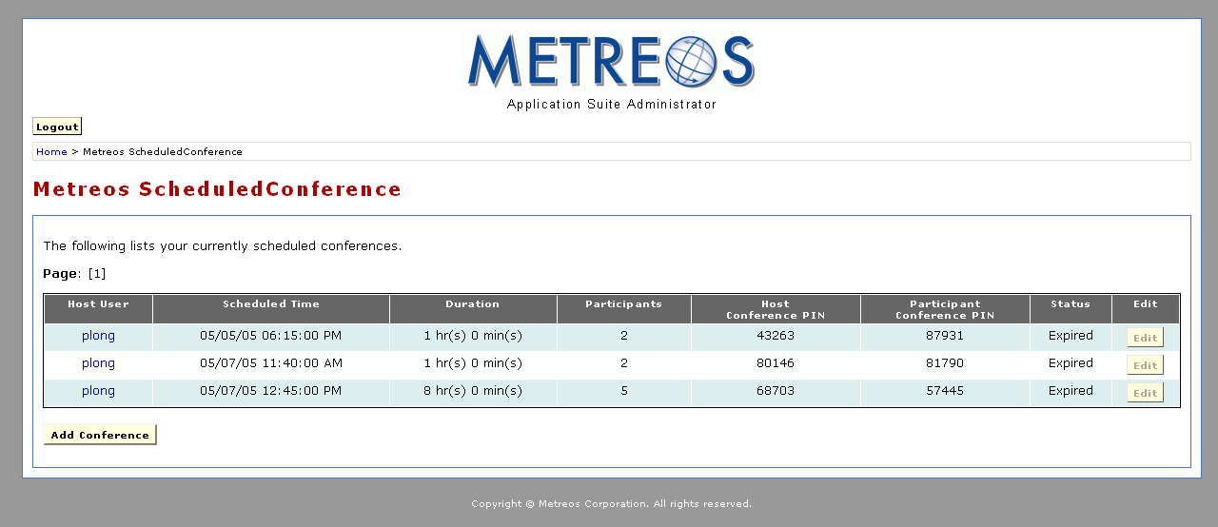
Figure 9: Metreos ScheduledConference Page
- Click the Add Conference button. The system presents the Schedule New Conference page:

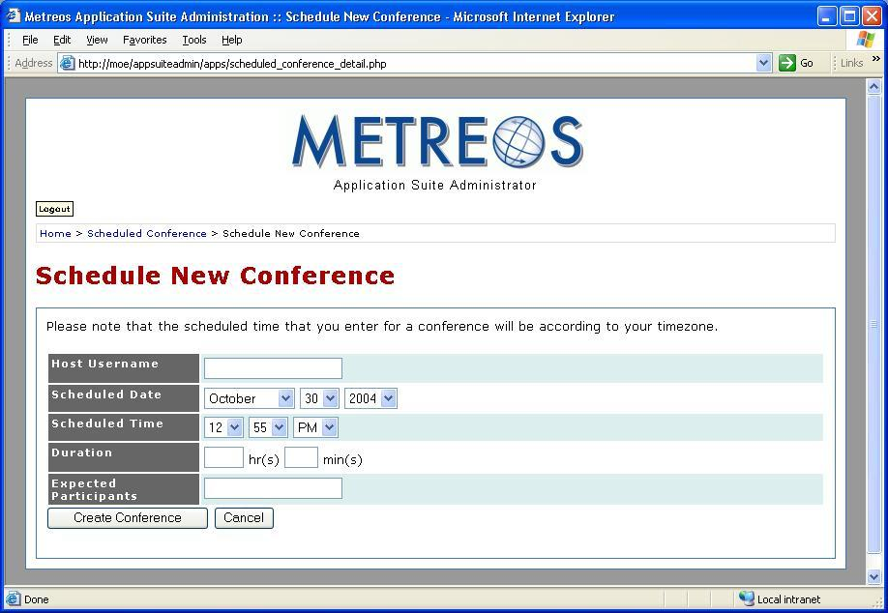
Figure 10: Schedule New Conference
- Fill out the form in accordance with the following list:

- Host Username – Enter your Metreos Application Suite user name.
- Scheduled Date – Select the date and time at which the conference will begin.
- Scheduled Time – Enter the expected conference start time.
- Duration – Enter the expected conference duration.
- Expected Participants – Enter the expected number of conference participants.

- Click the Create Conference button. The Edit Conference page is displayed with your conference information:

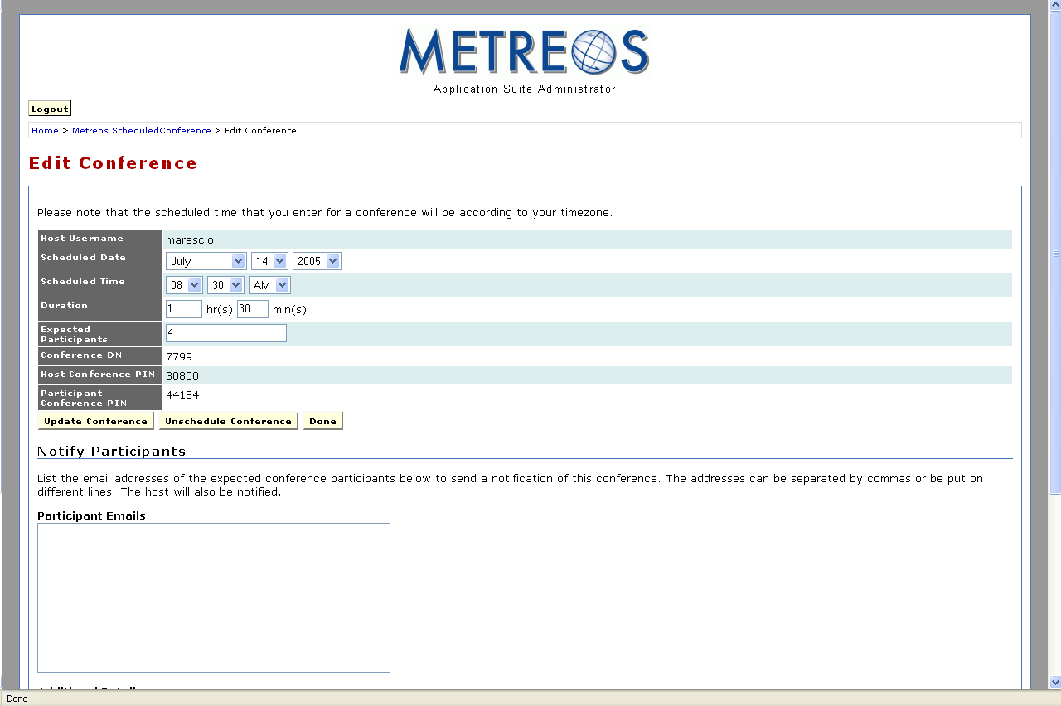
Figure 11: Edit Conference Page – Conference Details
The following list describes the conference information:

- Host Username – The username of the user hosting the conference
- Scheduled Date – The date on which the conference is scheduled
- Scheduled Time – The time on which the conference is scheduled to begin
- Duration – The length of time the conference is scheduled to last
- Expected Participants – The number of participants expected to attend
- Conference DN – Conference dial-in number (read only)
- Host Conference PIN – The Personal Identification Number (PIN) for the conference host (read only)
- Participant Conference PIN – The PIN for all other participants (read only)

You can edit the conference information at any time prior to the start time. The Edit Conference page also provides the option of notifying participants. Use the following procedure to do so:

- Scroll down the Edit Conference page to view the Participant Emails: and Additional Details: fields:

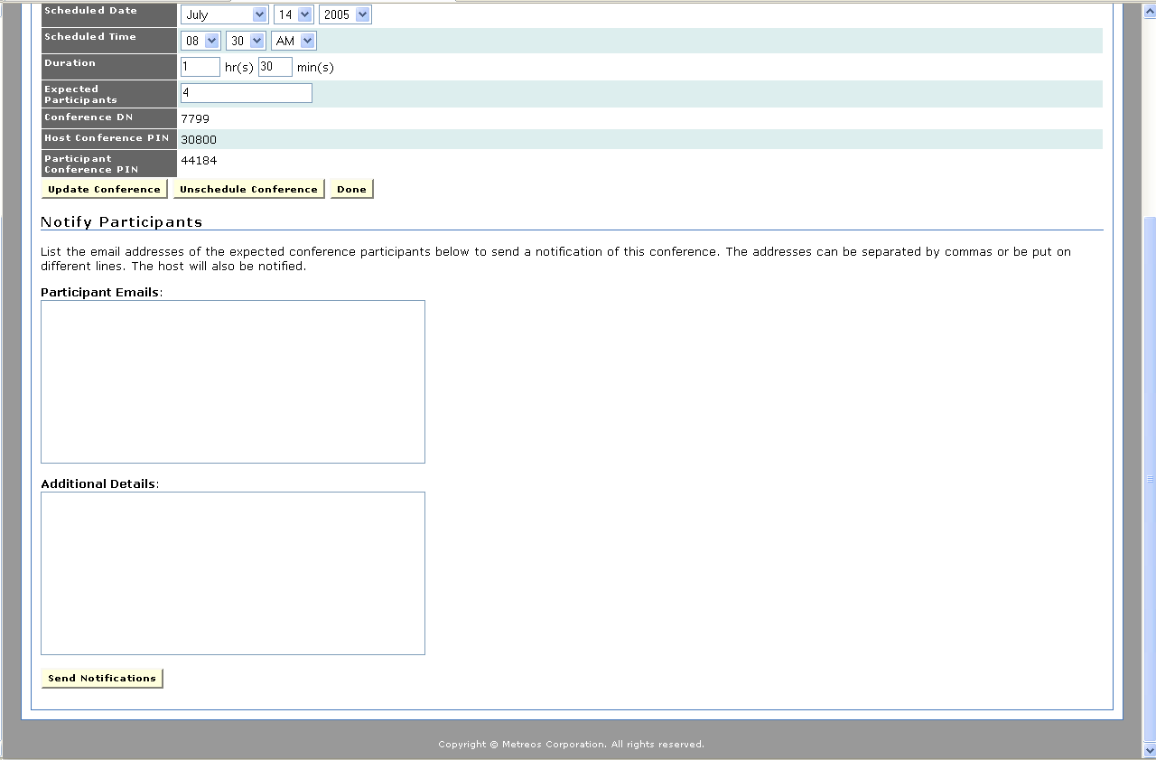
Figure 12: Edit Conference Page – Notify Participant
- Enter the following information:

- Participant Emails – The e-mail address for each participant you want to notify
- Additional Details – Any additional information you want to provide to the participants.

- Click the Send Notification button.

Dialing Into a Scheduled Conference
Use the following procedure to dial into a conference:

- Dial the assigned extension. The ScheduledConference attendant will ask you to enter your conference PIN, followed by the pound (#) key.
- If you scheduled the conference, key in the host PIN. If you are an invited participant, enter the participant PIN. The attendant will welcome you to the conference. As subsequent parties join the conference, the attendant will announce their arrival.

Metreos VoiceTunnel
Metreos VoiceTunnel allows a remote user to connect to any enterprise IP communications system and place calls as if they were local to the system. With Metreos VoiceTunnel you can

- Place all calls locally, avoiding international and long-distance toll charges
- Authenticate call usage and apply a broad range of policies to the billing and accounting of communications costs
- Manage, monitor, and report on the use of the communications system.

Using VoiceTunnel
To use Metreos VoiceTunnel

- Log into VoiceTunnel.
- Enter billing codes. Refer to Billing Codes for details.
- Enter the number to dial.

Logging into VoiceTunnel
To login to Metreos VoiceTunnel

- Retrieve the VoiceTunnel number, VoiceTunnel account number, and a Personal Identification Number (PIN) from your VoiceTunnel administrator.
- Call the VoiceTunnel number. VoiceTunnel plays a greeting, asking for your VoiceTunnel account number.
- Enter the account number with which you want to associate this call followed by the pound (#) key. You will be prompted to enter your PIN.
- Enter your PIN.

Billing Codes
Once you have logged in, you may be asked for a billing code, if VoiceTunnel has been so configured at your installation. Two billing codes are supported:

- Project code – VoiceTunnel uses project codes to associate a call with a project for accounting purposes. Enter the project code for your call, followed by the pound (#) key.
- Client code – VoiceTunnel uses client codes to associate a call with a called party. The client code is necessary because a specific party can be called at multiple destination numbers. The client code is a unique identifier for the party you are calling. Enter the client code in accordance with the dialing rules set by your administrator. The default configuration is to enter the client code followed by the pound (#) key.

Ending a Call
To end a call you have two options:

- Hang up – The call will end.
- Enter triple-pound (###) on the phone keypad – The call will end and you can begin another call using your current login and account information.

VoiceTunnel Error Conditions
This section presents the error conditions that could possibly occur during a VoiceTunnel session and possible causes and resolutions for each condition.

Note: All described voice announcements are those that ship with VoiceTunnel. Because announcements can be customized by an administrator, the wording for a particular announcement might differ from the description in this guide.

- Dialing into VoiceTunnel results in a busy signal – A busy signal indicates that you have dialed a number that has rejected your call. This condition can be caused by any of the following:
  - VoiceTunnel is not installed at your facility.
  - A VoiceTunnel or Application Suite configuration error exists.
  - There are no media ports available on the Metreos Media Server.
  - You dialed an incorrect number. If you have determined that the number you dialed is correct and the problem persists, contact your system administrator for resolution.
- VoiceTunnel answers the call and immediately hangs up – An immediate termination indicates that media resources could not be reserved on the media server. Although preliminary media reservations succeeded, no error message could be played, because your phone could not be connected to media resources. Contact your administrator for resolution of this problem.
- Audio prompt: The Secure Remote Access system is temporarily unavailable – This message is most likely to occur immediately after entering your PIN. In such cases, the message indicates that the application failed to communicate with the database or LDAP server containing the login account information. If the application is not configured to use LDAP, the problem originated with the database. If the application is configured to use LDAP, it will check the database first, then check LDAP if directed to do so by the database. Thus, in a LDAP configuration, the problem could originate either with LDAP or the database. Check the application server for details.
- Audio prompt: Your entry is invalid – This message usually indicates that you have taken too long to enter the requested information. If you have taken too long, the most recent prompt will be replayed, after which you can enter the information again.
- Audio prompt: The account or PIN you entered is invalid – This announcement indicates a failed login. You can retry to log in until the maximum number of failed login attempts is reached. If you reach the maximum number of failed login attempts your account will be locked, in which case contact your administrator.
- Audio prompt: This account is locked due to excessive failed login attempts – This message indicates too many failed attempts to log in to the system using the current account number. Depending on how the account is configured, the account may be automatically unlocked after a specified period of time. The account can always be manually unlocked by an administrator.
- Audio prompt: There are too many concurrent sessions using this account – This message indicates that the configured maximum number of users has been reached for the current account. You can either try your call again later or log in using a different account number.
- Audio prompt: Your personal identification number must be changed – This message does not indicate an error. Administrators can configure the system to require a PIN change the first time an account is used and the first time the account is used after a password reset. Enter a new PIN, and remember to notify other users of this account of the change.
- Audio prompt: The project code you entered is invalid – Ensure you have entered a valid project code for the call. If the problem persists, contact your administrator.
- Audio prompt: The client code you entered is invalid – Ensure you have entered a valid client code. If the problem persists, contact your system administrator.
- Audio prompt: You do not have permission to call this number – The administrator can restrict account access to specific destination numbers. You must either call a different number or log in using a different account code.
- Audio prompt: All lines are currently in use – This message indicates that there are no media resources available. Try your call again at a later time.
- Audio prompt: The call could not be connected because the line was busy – This message is equivalent to a traditional busy signal. You can either try a different number or try the call again later.
- Audio prompt: The call could not be connected because the line was not
answered – This message indicates that the dialed party did not answer the phone after a specified period of time. The time is specified as part of the Cisco CallManager configuration. Either try a different number or try the call again later.
- Audio prompt: The call could not be connected because the number was
unreachable – This message usually indicates that you entered an incorrect number. It is also possible, however, that a configuration problem exists at the remote gateway. If re-entering the number does not resolve the problem, contact your administrator.
- Audio prompt: Your call could not be completed – This message indicates that the system encountered an unknown error trying to place the call. A faulty CallManager configuration or other CallManager errors are possible causes. Contact your administrator.

The presence of any individual application in your deployment is dependent upon the license in effect.
By default you cannot begin a conference more than 15 minutes in advance of the scheduled start time. This threshold can however be modified by the administrator. You also cannot begin a conference at any time after the conference is scheduled to end.
This guide documents that all documented announcements are enabled at your installation. If you do not hear a particular announcement, simply skip forward in this document to the description of the announcement you are currently hearing.

